**Project: Explore Weather Trends**

**Name: Pranay Singla**

**Outline**

* **Data Extraction using SQL queries**

Query to extract global data:

*select * from global_data*

Query to extract data for my city:

*select * from city_data where city = 'Los Angeles' and country = 'United States'*

* **Data Manipulation and Moving average calculation**

I combined data from the 2 different csv files into 1 excel sheet. Then I calculated the 10-year moving average for both LA and global temperature data by using ‘AVERAGE’ function in excel, starting from the 10th observation and using the first 10 observations to calculate average.

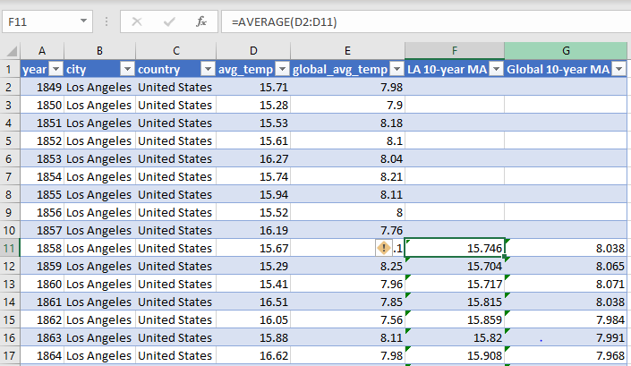

* **Visualization considerations**

Since we have data which changes over time, the line chart is the best type of chart to be used for visualization.

**Similarities**

* Although there’s not a linear increasing trend, the average temperature has increased over time both globally and in Los Angeles.

|  |  |  |
| --- | --- | --- |
| **Year** | **Global Avg Temperature** | **Los Angeles Avg Temperature** |
| 1858 | 8.038 | 15.746 |
| 2013 | 9.556 | 16.696 |

**Differences**

* The baseline avg. temperature in LA is around 16-degree Celsius whereas the baseline global average temperature is around 8-9 degree Celsius. So, in general, LA is hotter compared to the global average.
* Temperature is much more variable in LA and there’s no standard trend. The avg. temperature goes up and down around the 16-degree Celsius baseline between 1858 and 1972 before showing a much more linear increasing trend from 1978 to 2008. The global avg. temperature, on the other hand, shows a smooth linear increasing trend. However, it is not a steep curve and the change is very smooth.
* The average increase observed globally is more than the average increase observed in Los Angeles. If we compare the first and the last moving average observations, we can see that global temperature has increased by almost 1.5 degree on average compared to 1 degree increase in average temperature in Los Angles.

**Question 1) Is your city hotter or cooler on average compared to the global average? Has the difference been consistent over time?**

Los Angeles is hotter on average compared to the global average. The difference has not been consistent over time. Difference has ranged from a maximum of 8.029 degrees to a minimum of 6.902 degrees. The difference has changed from being close to around 7.8 degrees at the start (1858) to about 7.1 degrees towards the end (2008). This can be attributed to the much more increase in average global temperature to the smaller increase in temperature in LA over time.

**Question 2) How do the changes in your city’s temperatures over time compare to the changes in the global average?**

Temperature is much more variable in LA and there’s no standard trend. The avg. temperature goes up and down around the 16-degree Celsius baseline between 1858 and 1972 before showing a much more linear increasing trend from 1978 to 2008. The global avg. temperature, on the other hand, shows a smooth linear increasing trend. However, it is not a steep curve and the change is very smooth.

The average increase observed globally is more than the average increase observed in Los Angeles. If we compare the first and the last moving average observations, we can see that global temperature has increased by almost 1.5 degree on average compared to 1 degree increase in average temperature in Los Angles.

**Question 3) What does the overall trend look like? Is the world getting hotter or cooler? Has the trend been consistent over the last few hundred years?**

At an overall level, we see a smooth increasing trend. The world is getting hotter. The trend has not been consistent though. We see the avg. temperature going up and down initially between 1858 and 1918. After 1918, there’s a small increasing trend till around 1948. From 1948 to 1980, we see a flat line, i.e. the global average temperature remained almost constant. After 1980, we see a much faster increase in average temperature globally as average global temperature goes from 8.7 to 9.5 degree Celsius.